Elton Marumbwa

Donel Ntambwe

Emmanuel Olafisoye

Samuel Mogashoa

**XHAW5112**

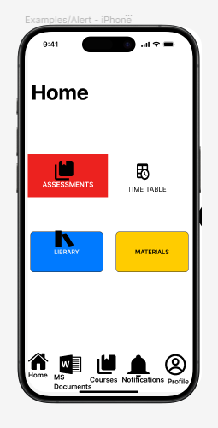

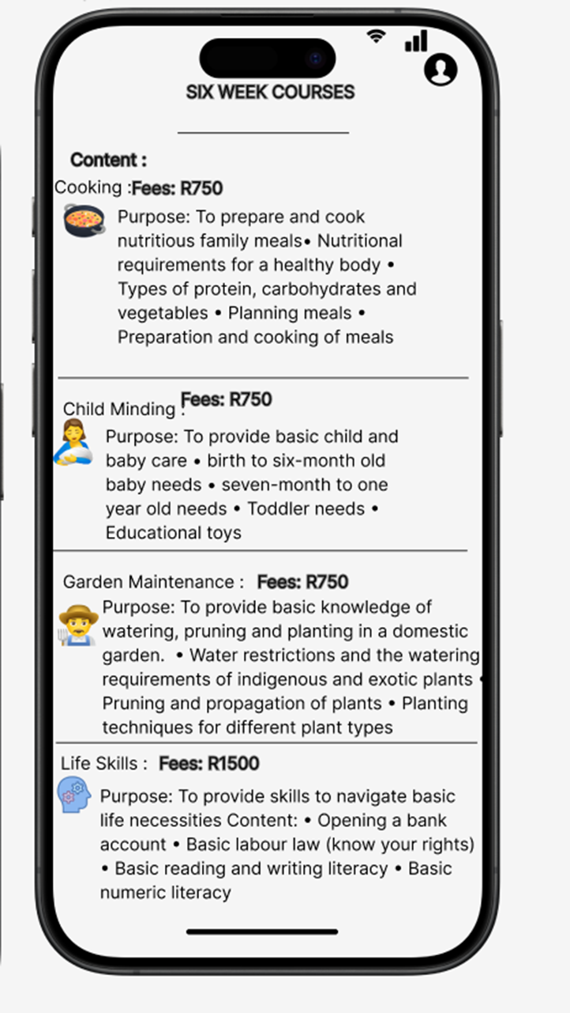

<https://github.com/st10453820/XHAW5112.git>

